Momentum practice with Unit conversions
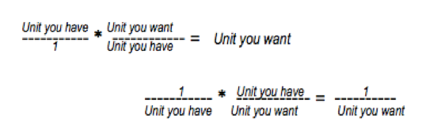
- What is the magnitude of the linear momentum of a 7.30 kg bowling ball going down the alley with a speed of 250.0 cm/s?
  - First: The velocity must be changed to meters per second. This one is done for you.
Conversion factor: 100 cm = 1 m
$$\frac{250.0 cm}{sec} x \frac{1 m}{100 cm }= \frac{250.0 cm m }{\sec{100 cm }}=\frac{250.0 m}{\sec{100}}= \frac{2.50m}{sec}=2.50 \frac{m}{s}$$

V = 250.0 cm/s = _______ m/s
  - Second: Calculate the momentum (now that you have mass in kg and velocity in m/s).

- Find the linear momentum of a 56.8 kg ball that is moving at 1600 km/hour.
  - First: The velocity must be changed to meters per second. You can do this one.
Conversion factors: 1000 m = 1 km and 1 hour = 3600 seconds
$$\frac{1600 km}{hour}x\frac{ m }{ km }x\frac{ hour }{ sec}=$$
  - Second: Calculate the momentum

- An aircraft is flying due east at 470 miles per hour. If the aircraft’s weight is 836,000 pounds, what is its momentum?
  - First: The velocity must be changed to meters per second.
Conversion factors: 1 mile = 1610 meters 1 hour = 3600 seconds
$$\frac{470 miles}{hour}x \frac{ m }{ mile}x \frac{ hour }{ seconds}=$$
  - Second: Find the mass using the weight. Conversion factors:
1 pound = 4.45 N 1 N = 0.102 kg

  - Third: Calculate momentum now that you have mass in kg and velocity in m/s.

- What is the mass of ball if it is moving at 4.7 feet/second and its momentum is 81 kg m/s?
  - First: The velocity must be converted to meters/second.
Conversion factor: 3.3 feet = 1 meter

  - Second: Solve for the mass using p = mv.

- The magnitude of the instantaneous momentum of a runner who is moving at 20.0 km/h is 479 kg-m/s. What is the runner’s mass?
  - First: The velocity must be converted to meters/second.
Conversion factors: ___ km = ________ meters ____ hours = _______ seconds

  - Second: Solve for the mass using p = mv.

