Impulse Review KEY
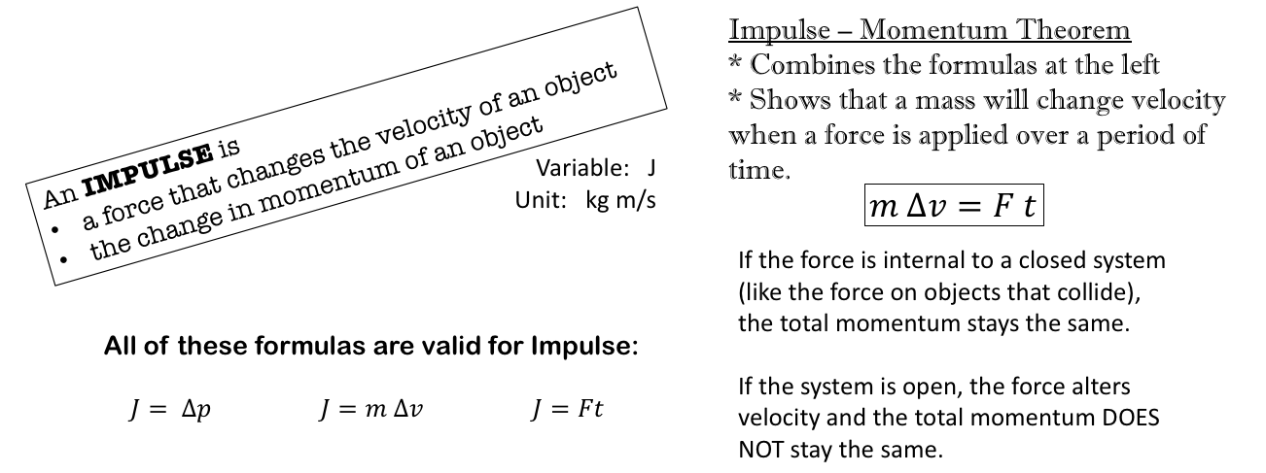

- An object with an initial momentum of 17 kg m/s is acted on by a force. Its momentum changes to -20 kg m/s.
  - If the mass of the object is 3 kg, what was its initial velocity? $p=mv$
$p=mv$ $17=3v$ v = 5.67 m/s
  - What was the impulse on the object? $J=∆p$
$$J=∆p= -20 -17= -37 kg\frac{m}{s}$$
  - What was the impulsive force (F) acting on the object if the force acted on the object for 0.5 seconds? $m∆v=Ft$
Note: J is the change in momentum (part b above). The left side of the formula $m∆v=Ft$ is change in momentum so you can use the solution in part b for the left side of the formula.
$m∆v=Ft$ $-37 =F(0.5)$ F = -74 N
- A 3.4 kg bat strikes an 0.45 kg ball. The bat is in contact with the ball for 0.034 seconds. If the change in velocity of the ball is 93 m/s, what was the force on the ball? $m∆v=Ft$
Note: You are looking for the force on the ball so you use the mass of the ball ONLY.
$m∆v=Ft$ $(0.45)(93) =F(0.034)$ F = 1231 N
- A 52 kg soccer player kicks 0.40 kg ball. The kicker’s foot contacts the ball for 0.084 seconds. If the change in velocity of the ball is 33 m/s, what was the force on the ball?
$m∆v=Ft$ $(0.40)(33) =F(0.084)$ F = 157.1 N
- A 2 kg block strikes another 2 kg block. The blocks are moving at the same speed but in opposite directions (they collide head-on). The force on each block is 650 N. The blocks come to a stop in 0.35 seconds. How fast were they travelling when the collision occurred?
$m∆v=Ft$ $(2)(0-v_{i}) =(650)(0.35)$ v_{i} = -113.75 m/s
- In a car accident, two identical cars collide head-on and come to a complete stop. The red car exerts a force of 69,000 N on the 3500 kg blue car. If the time to come to a stop is 0.012 seconds, how fast was the red car traveling immediately before the impact?
$m∆v=Ft$ $(3500)(0-v_{i}) =(69000)(0.012)$ v_{i} = -0.237 m/s

