Impulse Review
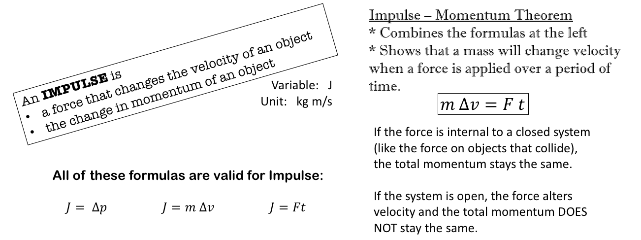

- An object with an initial momentum of 17 kg m/s is acted on by a force. Its momentum changes to -20 kg m/s.
  - If the mass of the object is 3 kg, what was its initial velocity? $p=mv$

  - What was the impulse on the object? $J=∆p$

  - What was the impulsive force (F) acting on the object if the force acted on the object for 0.5 seconds? $m∆v=Ft$

- A 3.4 kg bat strikes an 0.45 kg ball. The bat is in contact with the ball for 0.034 seconds. If the change in velocity of the ball is 93 m/s, what was the force on the ball? $m∆v=Ft$

- A 52 kg soccer player kicks 0.40 kg ball. The kicker’s foot contacts the ball for 0.084 seconds. If the change in velocity of the ball is 33 m/s, what was the force on the ball?

- A 2 kg block strikes another 2kg block. The blocks are moving at the same speed but in opposite directions (they collide head-on). The force on each block is 650 N. The blocks come to a stop in 0.35 seconds. How fast were they travelling when the collision occurred?

- In a car accident, two identical cars collide head-on and come to a complete stop. The red car exerts a force of 69,000 N on the 3500 kg blue car. If the time to come to a stop is 0.012 seconds, how fast was the red car traveling immediately before the impact?

