Momentum Practice Name: _______________A

Dimension | Variable | Standard  International  Unit | Definition
Mass
Velocity
Momentum
Impulse

Momentum Formula: Impulse Formula:

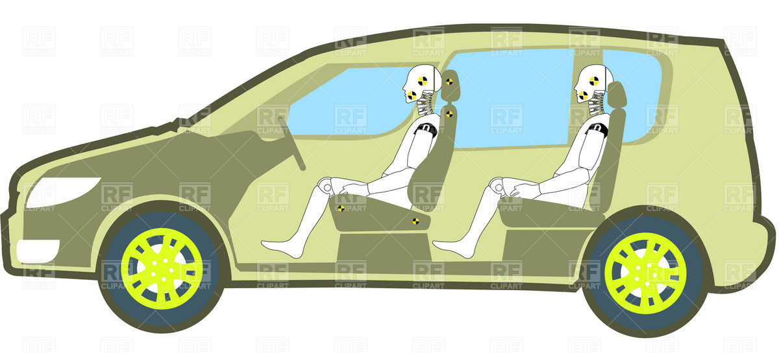
m_{car} = 2000 kg
m_{person}= 35 kg

- Find the momentum of the car with two people inside if it is
  - travelling at 20 m/s.

  - travelling at 40 m/s.

- What is the momentum of just one person at the speeds listed in #1.

- What are the two variables that determine momentum?

- Use the momentum, mass and velocity of 1. a. answer the following:
  - What is the impulse on the car if it comes to a stop?
  - What is the force on the car comes to a stop in 0.34 seconds?

- What is the best way to reduce the forces on people in car crashes?

Basic momentum calculations

- What is the momentum of a 0.06 kg egg if it is at rest?

- What is the momentum of a 0.06 kg egg if it is moving at 10 m/s?

- What is the velocity of a 0.06 kg egg if its momentum is 1.2 kg m/s?

- Find the mass of a ball that is moving at 74 m/s if it’s momentum is 37 kg m/s.

- A 5 kg crate’s momentum increases from 35 kg m/s to 55 kg m/s.
  - What is the crate’s starting velocity?

  - What is the crate’s ending velocity?

  - What is the impulse on the crate during the change in momentum?

  - What Force was applied if the crate changed momentum in 3 seconds?

- Two bullets have the same momentum. If their mass is the same, how do their velocities compare?

- If a car’s momentum is 56,000 kg m/s in the positive direction, what is the direction of the car’s velocity? Why?

