Elastic and Inelastic Collisions with Conservation of Momentum
Visit the website http://phet.colorado.edu/en/simulation/collision-lab To complete the following:
- Inn the right side of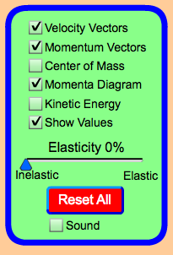 .
In the green box on the right side of the screen, select the settings shown on the left. Be sure to move the slider to the left so elasticity is 0%.

Click play.
  - Describe what happens to the balls after they collide.

____________________________________________________________________
Click on Restart. Move the slider so elasticity is 100%. Click play.
  - Describe what happens to the balls after they collide.

____________________________________________________________________

  - Which has the greater momentum?

- Complete the sentences: In a perfectly elastic collision, the objects ______________ one another.
In a perfectly inelastic collision, the objects_____________ together.

- Test what happens when balls are the SAME MASS in collisions. Change the mass of the balls to 1 kg each. Push “play” and let the balls collide. After they collide and you see the vectors change, click “pause”. Click “rewind” and watch the momenta box during the collision. Watch it more than once if needed by using “play”, “rewind”, and “pause”. Zoom in on the vectors in the momenta box with the control on the right of the box to make it easier to see if necessary.

Before the collision |  |  |  | After the collision
RED ball |  | GREEN ball |  | RED ball |  | GREEN ball
Mass= 1 kg | Velocity | Mass= 1 kg | Velocity  V₂ = 0 m/s | Mass= 1 kg | Velocity | Mass= 1 kg | Velocity
Momentum= |  | Momentum= |  | Momentum= |  | Momentum=
Total momentum before = |  |  |  | Total momentum after =

Move the slider to the left so the collision is perfectly inelastic. Repeat the steps in #2.

Before the collision |  |  |  | After the collision
RED ball |  | GREEN ball |  | RED ball |  | GREEN ball
Mass= 1 kg | Velocity | Mass= 1 kg | Velocity  V₂ = 0 m/s | Mass= 1 kg | Velocity | Mass= 1 kg | Velocity
Momentum= |  | Momentum= |  | Momentum= |  | Momentum=
Total momentum before = |  |  |  | Total momentum after =

What happens to momentum in ELASTIC & INELASTIC COLLISIONS when the mass is the same?

- Test what happens when balls are DIFFERENT MASS in collisions. Move the slider to the left so the collision is perfectly elastic. Change the mass of the GREEN BALL to 3 kg. Leave ball 1’s mass at 1 kg. Complete the table.

Before the collision |  |  |  | After the collision
Ball 1 |  | Ball 2 |  | Ball 1 |  | Ball 2
Mass  m₁ = 1 kg | Velocity | Mass  m₂ = 3 kg | Velocity  V₂ = 0 m/s | Mass  m₁ = 1 kg | Velocity | Mass  m₂ = 3 kg | Velocity
Momentum= |  | Momentum= |  | Momentum= |  | Momentum=
Total momentum before = |  |  |  | Total momentum after =

- Move the slider to the left so the collision is perfectly inelastic. Repeat the steps in #3.

Before the collision |  |  |  | After the collision
Ball 1 |  | Ball 2 |  | Ball 1 |  | Ball 2
Mass  m₁ = 1 kg | Velocity | Mass  m₂ = 3 kg | Velocity  V₂ = 0 m/s | Mass  m₁ = 1 kg | Velocity | Mass  m₂ = 3 kg | Velocity
Momentum= |  | Momentum= |  | Momentum= |  | Momentum=
Total momentum before = |  |  |  | Total momentum after =

What happens to momentum IN ELASTIC & INELASTIC COLLISIONS when the mass is different?

- Test what happens when balls have the SAME SPEED IN OPPOSITE DIRECTIONS in collisions. Next, you will change the mass of the balls and the starting velocity of the balls. You can choose the mass you want to use, but be sure both balls have the same mass. Next, select a starting speed for the balls but make them opposite signs so the balls move toward each other.

Before the collision |  |  |  | After the collision
Ball 1 |  | Ball 2 |  | Ball 1 |  | Ball 2
Mass | Velocity | Mass | Velocity | Mass | Velocity | Mass | Velocity
Momentum= |  | Momentum= |  | Momentum= |  | Momentum=
Total momentum before = |  |  |  | Total momentum after =

- Move the slider to the left so the collision is perfectly inelastic. Repeat the steps in #5.

Before the collision |  |  |  | After the collision
Ball 1 |  | Ball 2 |  | Ball 1 |  | Ball 2
Mass | Velocity | Mass | Velocity | Mass | Velocity | Mass | Velocity
Momentum= |  | Momentum= |  | Momentum= |  | Momentum=
Total momentum before = |  |  |  | Total momentum after =

SUMMARIZE THE MOMENTUM TRANSFERS IN ELASTIC & INELASTIC COLLISIONS WHEN THE MASS IS THE SAME & THE STARTING SPEEDS ARE EQUAL & OPPOSITE DIRECTIONS.

- Test what happens when balls have the DIFFERENT SPEEDS IN SAME DIRECTION in collisions. Next, you will change the mass of the balls to 2 kg each. Make the starting velocity of ball one + 2 m/s and the starting velocity of the ball two +1 m/s.

Before the collision |  |  |  | After the collision
Ball 1 |  | Ball 2 |  | Ball 1 |  | Ball 2
Mass | Velocity | Mass | Velocity | Mass | Velocity | Mass | Velocity
Momentum= |  | Momentum= |  | Momentum= |  | Momentum=
Total momentum before = |  |  |  | Total momentum after =

- Move the slider to the left so the collision is perfectly inelastic. Repeat the steps in #9.

Before the collision |  |  |  | After the collision
Ball 1 |  | Ball 2 |  | Ball 1 |  | Ball 2
Mass | Velocity | Mass | Velocity | Mass | Velocity | Mass | Velocity
Momentum= |  | Momentum= |  | Momentum= |  | Momentum=
Total momentum before = |  |  |  | Total momentum after =

SUMMARIZE THE MOMENTUM TRANSFERS IN ELASTIC & INELASTIC COLLISIONS WHEN THE SPEED IS THE DIFFERENT.

- Experiment a little by running additional simulations. If you wish to try collisions that are not perfectly elastic (100%) or perfectly inelastic (0%), you can try that. Record the following data for at least 2 additional simulations.
Mass of Red Ball | Mass of Green Ball | % elasticity | Red and Green Momentum vectors before crash | Red and Green Momentum vectors after crash | Change in total momentum during simulation? (yes or no)

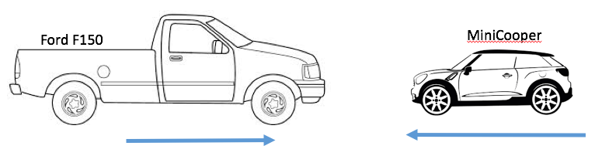
APPLICATION:

Use momentum to explain whether a Ford F150 is a safer vehicle than a Mini-Cooper in a head-on collision where each vehicle is moving at the same speed.

In your response, discuss the effects that mass and velocity will have on the vehicles’ momentum. In addition, describe whether you expect the collision to be elastic or inelastic.

